What did school council think?
- Pleased at more money being invested in rewards
- Want a range of vouchers instead of just WHS
- Prom ticket idea well received
- Agreed with new DT system
- Like the idea that students know what could happen next and that they would be warned before further action
- Very much against whole class sanctions and think new system helps prevent this, focussing on individuals.

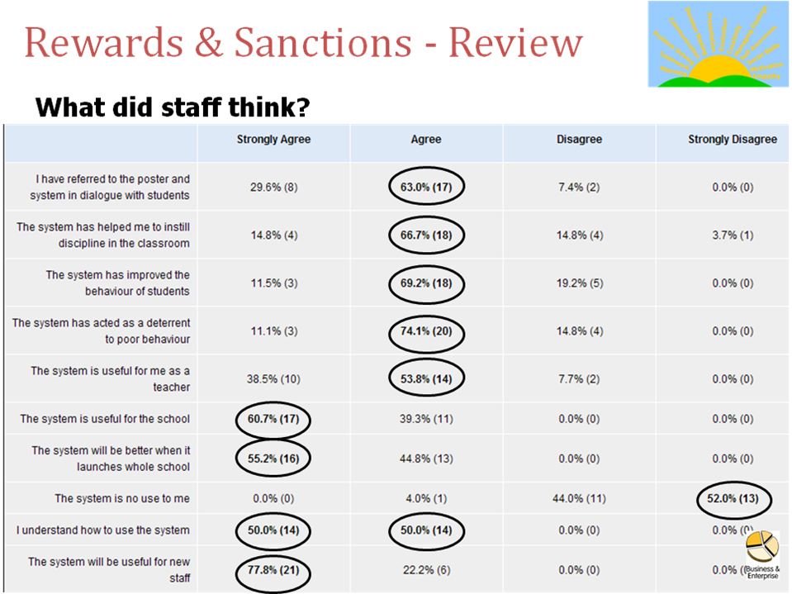
What Now?
- The system launches for the whole school immediately
- Letters have gone home to parents
- Assemblies will take place to explain to students this week
- Use it straight away BUT be aware that students may not know fully until the latter part of the week.

Recap - How does it work?
- Dialogue on poster to be used with students.
- Positive rewards actioned
- Sanctions system actioned
- System to be consistently used by all staff leading to students understanding where they stand and knowing what to expect.
Positive Rewards?
- Praise & Encouragement
- Credits – ALL YEAR GROUPS – leading to new rewards prizes
- Letters home where appropriate
- Department policies as required
- End of year trip – to be arranged by Learning Manager
 | Years 7-10 | Year 11
50 Credits | School X USB Memory Stick
100 Credits | £5 Voucher | £5 voucher OR £5 off Prom Ticket
150 Credits | £10 Voucher | £10 voucher OR £10 off Prom ticket
200 Credits | £15 voucher | £15 voucher OR £15 off Prom ticket

Sanctions System?
- Use your pad – one form for all DTs
- Procedure –
  - Verbal warning
  - Loss of behaviour star (may also move seat/remove temp)
  - Issue DT1 – Subject staff
  - Carry out DT1
  - If attends start a fresh next time
  - If not give another chance without issuing a new form
  - If ‘no show’ again then refer to HOD for DT2
  - Auto system then picks up attendance
  - If major incident or LM/SLT feels necessary they may issue DT3/DT4

Trail main issues/comments?
- Admin role is vital – get forms to office ASAP
- Students have a right to the verbal & written warning first
- DT1s must be in school time
- Only Subject Leaders can issue DT2s
- Only Learning Managers can issue DT3s
- Only Senior Leaders can issue DT4s
- Leadership pick ups not fair so staff to record students sent out on uniform card.
- Staff running DT are on rota displayed in staff room, they should collect/return the relevant blue box from reception
- Students may turn up earlier than staff!
- Incident forms remain for serious incidents
- Consistency from all staff is key!

